EXPERIMENT NO. 7
Unique Elements from a List
Programming Language: Java
Name : A Yuvan Charan
Register No. : 192424383
Aim
To write a Java program that creates a new list containing only the unique elements of the input list and to find its space complexity.
Question
Write a program that takes an input list of n numbers and creates a new list containing only the unique elements from the original list. What is the space complexity of the algorithm?
Test Case 1 - Some Duplicate Elements
Input: [3, 7, 3, 5, 2, 5, 9, 2]
Expected Output: [3, 7, 5, 2, 9] (order may vary)
Test Case 2 - Negative and Positive Numbers
Input: [-1, 2, -1, 3, 2, -2]
Expected Output: [-1, 2, 3, -2] (order may vary)
Test Case 3 - List with Large Numbers
Input: [1000000, 999999, 1000000]
Expected Output: [1000000, 999999]
Algorithm
Step 1: Start.
Step 2: Read the input list a of size n. Create an empty result list res and an empty HashSet seen.
Step 3: For each element x of a, try to add x to seen.
Step 4: If x was not already present in seen, append x to res.
Step 5: Print the list res.
Step 6: Stop.
Program (Java)
import java.util.ArrayList;
import java.util.HashSet;
import java.util.List;
import java.util.Set;

public class Main {

static List<Integer> unique(int[] a) {
Set<Integer> seen = new HashSet<>();
List<Integer> result = new ArrayList<>();
for (int x : a) {
if (seen.add(x)) // add() returns false if x is already present
result.add(x);
}
return result;
}

public static void main(String[] args) {
int[] t1 = {3, 7, 3, 5, 2, 5, 9, 2};
int[] t2 = {-1, 2, -1, 3, 2, -2};
int[] t3 = {1000000, 999999, 1000000};

System.out.println("Output: " + unique(t1));
System.out.println("Output: " + unique(t2));
System.out.println("Output: " + unique(t3));
}
}
Output
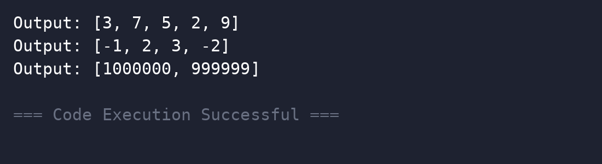
Complexity Analysis
Time Complexity: O(n) on average - each element is checked and inserted in the HashSet in O(1) expected time (O(n^2) if a plain list search is used instead).
Space Complexity: O(n) - the HashSet and the result list can each hold up to n elements when all elements are distinct.
Result
Thus the program was executed successfully and the output was verified.

